RESUME

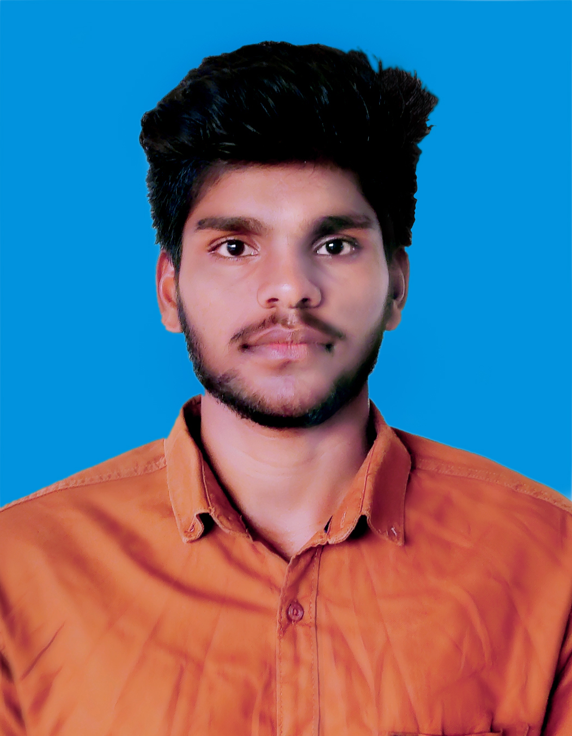
RAVI KUMAR P
Address : Chandravanam Estate,Vandiperiyar
Idukki(Dt),Kerala
Pin:685533

Mobile : +91-8086861395
E-Mail : pravikumar014@gmail.com

CAREER OBJECTIVE

Looking for a challenging career which demands the best of my professional ability in terms of technical and analytical skills and helps me in enhancing my current skill and knowledge.

ACADEMIC QUALIFICATION

B.E Anna University, Chennai (2016-2020)
Computer Science Engineering
MET Engineering College, Aralvaimozhi.
HSC From Govt hr sec school (2015-2016) 68.5%
Rajankam Govt Kallar Higher Secondary School, Gudalur.

SSLC Tamil Nadu State Board (2013-2014) 73%
CPU Higher Secondary School, Cumbum.

AREA OF INTEREST

  - Software Engineer
  - Network Admin
  - Hardware Engineer

SKILLS

- Team worker
- Willingness to learn.

CO CURRICULAR ACTIVITIES
- Participated in one-day workshop on “HARDWARE AND NETWORK" in my college.
- Participated in one-day workshop “CODING TECHNOLOGIES - ANGULAR JS(.net)" at GIFT WEB SOLUTIONS, Nagercoil.

ACHIEVEMENTS
- I have attend Internship in "ADVANCE .NET TECHNOLOGY" for one month at
CENTAURUSS.

COMPUTER SKILLS
- C
- C++
- Java

PERSONAL DETAILS

Father’s Name : Mr.Pandiyan
Mother’s Name : Mrs.Lakshmi P
Gender : Male
Date of Birth : 30-05-1999
Nationality : Indian
Known Languages:
Tamil - Read, Write, Speak
Malayalam. - Read, Speak
English - Read, Write, Speak
Hobbies. : Cricket, Volleyball, Swimming.

ACADEMIC PROJECT

- Collusion Defender
- Description : secure information sharing in E - Health services
become using cryptography with key setup.
- Duration : 3 months.
.
DECLARATION

I hereby declare that all the above said facts are true to the best of my knowledge.

Date:

Place: [RAVI KUMAR

